
Dashboard Design

Date | 29 July 2026
Team ID | OBUVARSHINI O
Project Name | GLOBAL AI EDUCATION
Maximum Marks | 5 Marks

Activity 1: Interactive and Visually Appealing Dashboards

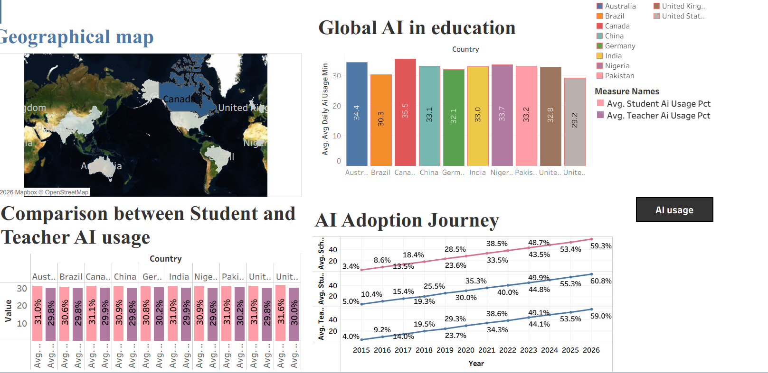

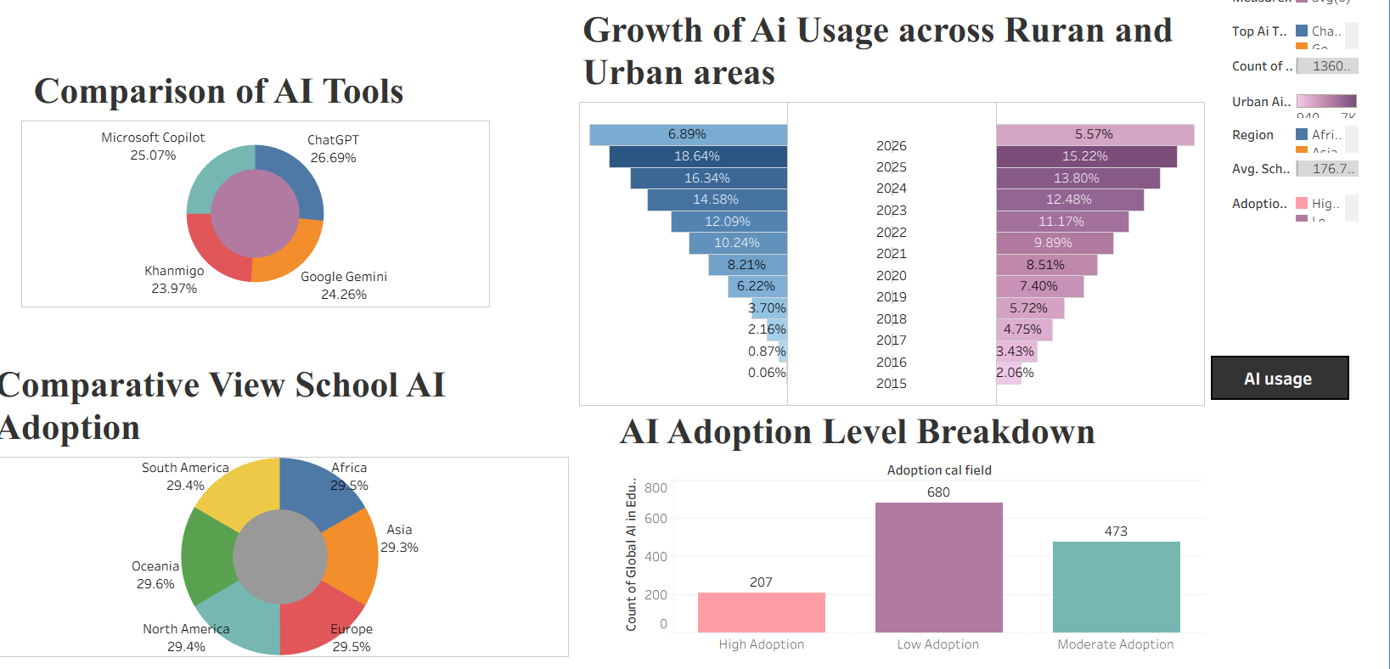The AI Adoption Journey line chart demonstrates a steady increase in school AI adoption, student AI usage, and teacher AI usage from 2015 to 2026. This highlights the growing importance of AI technologies in modern education systems worldwide.

The comparative bar chart reveals that students consistently show slightly higher AI usage rates than teachers across most countries, indicating faster adoption of emerging AI tools among learners.

The regional comparison donut chart illustrates that AI adoption is distributed across all major regions, confirming that AI integration in education is a global phenomenon rather than being limited to specific continents.

The AI Tools comparison chart highlights the usage distribution of ChatGPT, Google Gemini, Microsoft Copilot, and Khanmigo. ChatGPT emerges as the most widely used AI tool, reflecting its popularity in educational activities.

The growth visualization shows increasing AI adoption in both urban and rural communities over time, demonstrating improved accessibility and narrowing of the digital divide in education.

Through interactive filters and visual controls, users can dynamically explore AI adoption trends by country, region, year, and educational category, enabling deeper analysis and data-driven educational insights.

Activity 2: Live Deployment Link
Below is the public access link to the interactive visualization dashboard:
https://public.tableau.com/app/profile/obuvarshini.o7003/viz/tableauproject1Dashboard/Dashboard1?publish=yes
https://public.tableau.com/app/profile/obuvarshini.o7003/viz/tableauproject1Dashboard2/Dashboard2?publish=yes

